2.41: a) If the meter stick is in free fall, the distance d is related to the reaction time t by 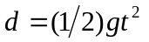, so 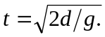 If d is measured in centimeters, the reaction time is
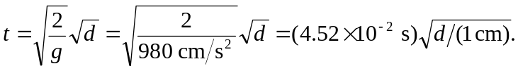

b) Using the above result, 